March 11, 2012
Introduction to “To One Another Young Adults Ministries”
서로에게 “Young Adults” 사역 소개
Group Question:
There are many verses in Scriptures that tell us to do unto another. Which do you think you need to work on the most?
By the way, why do you think Scripture talks about being to one another?

We are “Young Adult” Ministries
- College, Graduates, Young Working People (Ages 18-39)
- Married and Unmarried people
- Unbelievers, Believers with questions, Believers that desire to help unbelievers to come to know God
Let’s start with our logo – can anyone describe what this logo means?

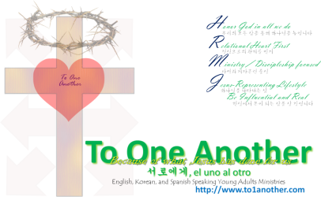

Through our gatherings, let us:
1. Worship (Transcendence, come meet the God who is beyond grasp and understanding)
2. Pray (Language of Intimacy, find significance of our lives by personally communing with our God)
3. Come Together (Form a community because of God's love for us).

I am because we are
우리이기 때문에 내가 존재 한다
yo soy porque nosotros somos

Real people that Genuinely come together to have an Authentic relationship with a True God
- We encourage practicality; let’s learn from each other to draw close to God through our daily lives
- We encourage asking of questions (Use the website or the box at the church)
- We encourage individual sharing and group discussions, to talk about real life issues and challenges
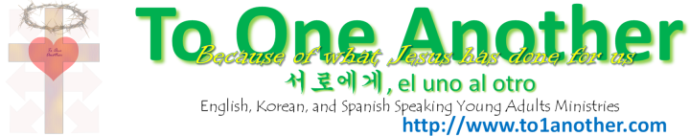
- We encourage gathering often (following Hebrews 10:25), this will bring about community
And let us not neglect our meeting together, as some people do, but encourage one another, especially now that the day of his return is drawing near.

Communion (성찬식) – It’s about what Jesus has done, that brought us forgiveness and belonging
Luke 22:19-20
19 He took some bread and gave thanks to God for it. Then he broke it in pieces and gave it to the disciples, saying, “This is my body, which is given for you. Do this to remember me.” 20 After supper he took another cup of wine and said, “This cup is the new covenant between God and his people—an agreement confirmed with my blood, which is poured out as a sacrifice for you.
19 또 떡을 가져 사례하시고 떼어 저희에게 주시며 가라사대 이것은 너희를 위하여 주는 내 몸이라 너희가 이를 행하여 나를 기념하라 하시고20 저녁 먹은 후에 잔도 이와 같이 하여 가라사대 이 잔은 내 피로 세우는 새 언약이니 곧 너희를 위하여 붓는 것이라
Those who are in Jesus are to remember what He has done.
Wine represents the blood of Jesus – we remember that it was His love and death that took away our sins
Bread represents that we now belong and are one in Christ – because of Him, we can now relate with God

We’ll eat and drink the bread and wine together in unison. Spend some time reflecting on and repenting of your sins, and express your gratefulness to God for what He has done.
1 Corinthians 11:27-29
27 So then, whoever eats the bread or drinks the cup of the Lord in an unworthy manner will be guilty of sinning against the body and blood of the Lord. 28 Everyone ought to examine themselves before they eat of the bread and drink from the cup. 29 For those who eat and drink without discerning the body of Christ eat and drink judgment on themselves.
27 그러므로 누구든지 주의 떡이나 잔을 합당치 않게 먹고 마시는 자는 주의 몸과 피를 범하는
죄가 있느니라28 사람이 자기를 살피고 그 후에야 이 떡을 먹고 이 잔을 마실찌니29 주의
몸을 분변치 못하고 먹고 마시는 자는 자기의 죄를 먹고 마시는 것이니라
To One Another, 서로에게, el uno al otro

Love
사랑하라
Amémonos

Honor
존경하라
Respetándose y honrándose
Romans 12:10

Live in Harmony
마음을 같이하라
Vivan en armonía
Romans 12:16

Stop Condemning
비판하지 말아라
Dejemos de juzgarnos
Romans 14:13

Accept
따뜻이 맞아들이라
Acéptense
Romans 15:7

Instruct and counsel
가르치고 권면하라
instrúyanse y aconséjense
Romans 15:14,Colossians 3:16

Greet
인사를 나누라
Salúdense
Romans 16:16,1Corinthians 16:20;2Corinthians 13:12,1Peter 5:14

Agree
한마음 한뜻으로 굳게 연합하라
Mantengemos unidos en un mismo pensar y en un mismo propósito
1Corinthians 1:10

Encourage
격려하고 위로하라
Anímense y edifíquense
2Corinthians 13:11,1Thessalonians 4:18,1Thessalonians 5:11,Hebrews 3:13

Serve
섬기라
Sírvanse
Galatians 5:13

Be Humble,Gentle,Patient,and Bear
겸손하고 부드러우며 인내와 사랑으로 너그럽게 대하라
Humildes y amables,pacientes,tolerantes
Ephesians 4:2

Be Kind and Compassionate
친절하게 대하고 불쌍히 여기라
Sean bondadosos y compasivos
Ephesians 4:32

Forgive
용서하라
Perdónense
Ephesians 4:32

Speak in Psalms,Hymns,and Songs from the Spirit
시와 찬미와 영적인 노래로 이야기하라
Anímense con salmos,himnos y canciones espirituales
Ephesians 5:19

Submit
복종하라
Sométanse
Ephesians 5:21

Bear with and Forgive
참으며 용서하라
Toleren y perdonen
Colossians 3:13

Encourage Towards Love and Good Deeds
격려하여 사랑과 선한 일을 위해 힘쓰도록 하라
Preocupémonos a fin de estimularnos al amor y a las buenas obras
Hebrews 10:24

Not Giving Up Meeting Together but Encourage
모이기를 중단하지 말고 격려하라
No dejemos de congregarnos,sino animémonos
Hebrews 10:25

Do Not Slander
헐뜯지 말아라
No hablen mal
James 4:11

Do Not Grumble against
원망하지 말라
No se quejen
James 5:9

Be Like-minded with, Be Sympathetic, Compassionate, and Humble to, and Love
한마음으로 동정하고 형제처럼 사랑하고 불쌍히 여기며 겸손하라
Vivan en armonía,compartan penas y alegrías,practiquen el amor fraternal,sean compasivos y humildes
1Peter 3:8

Offer Hospitality
대접하라
Practiquen la hospitalidad
1Peter 4:9

Clothe Yourselves with Humility toward one another
겸손한 마음으로 섬기라
Revístanse todos de humildad
1Peter 5:5

